**Meeting 17/02/21 Notes**

* Results below found and discussed. Finished sentiment analysis showing it has definitely picked up on some words that are more likely to make a male/female annotator label the comment toxic. This proves that there is a difference between annotations made by men and women and this can be picked up on by a machine learning model, highlighting the importance of diversity of opinion.

**This week’s results:**

In Toxic_BERT_Sentiment.ipynb (with MAX_LEN = 100):

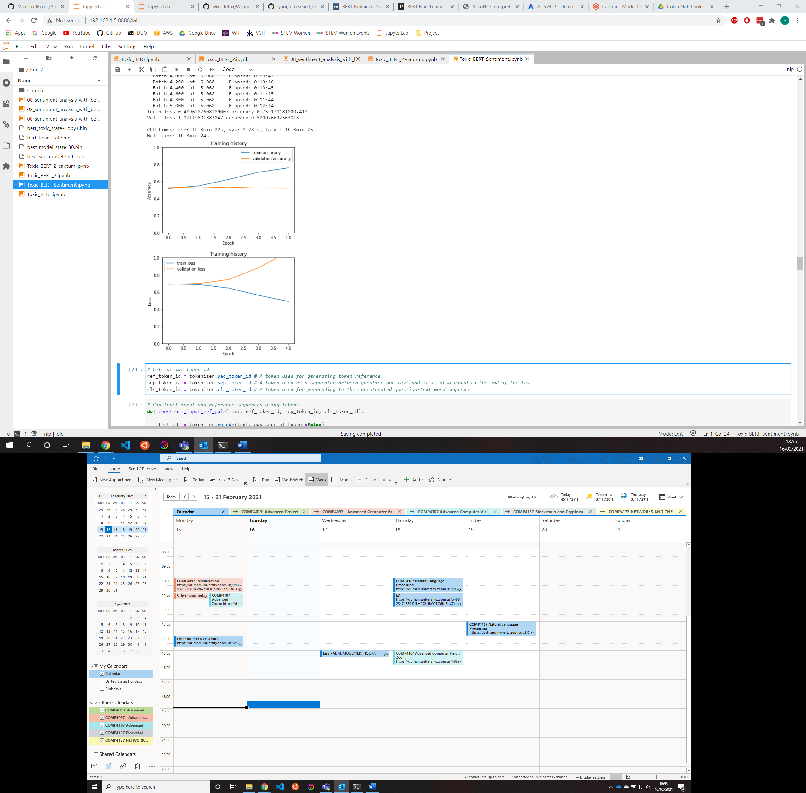

Loss and accuracy graphs over 5 epochs – overfitting?

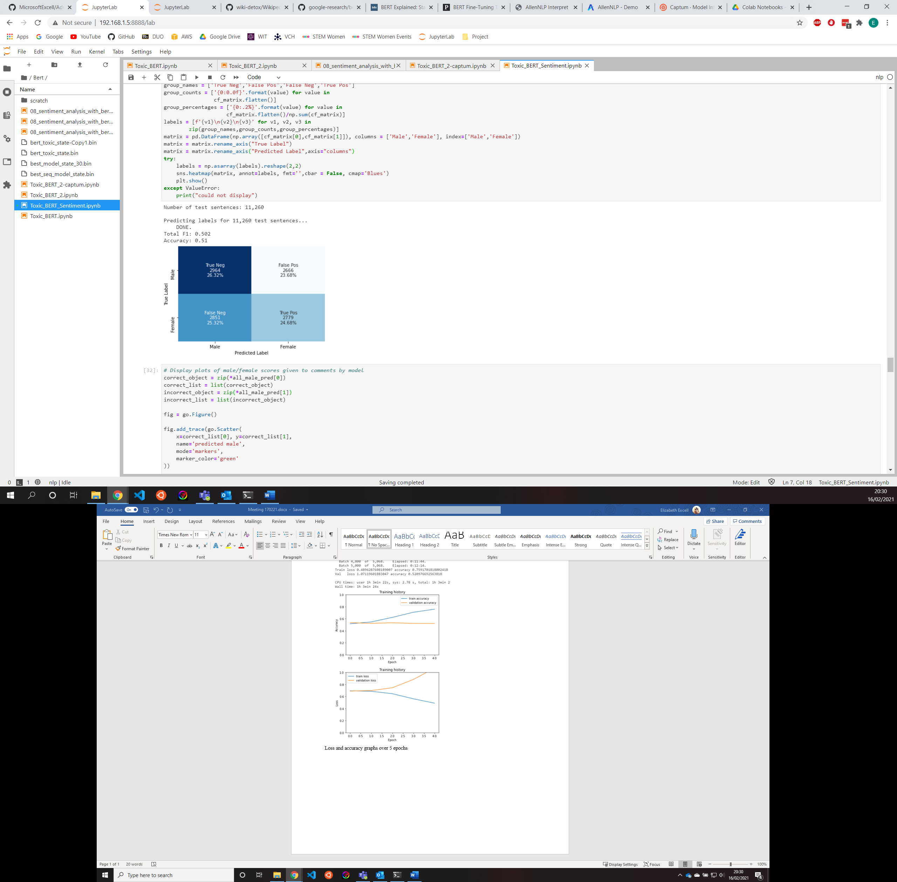

Overfitting – can see from previous graphs

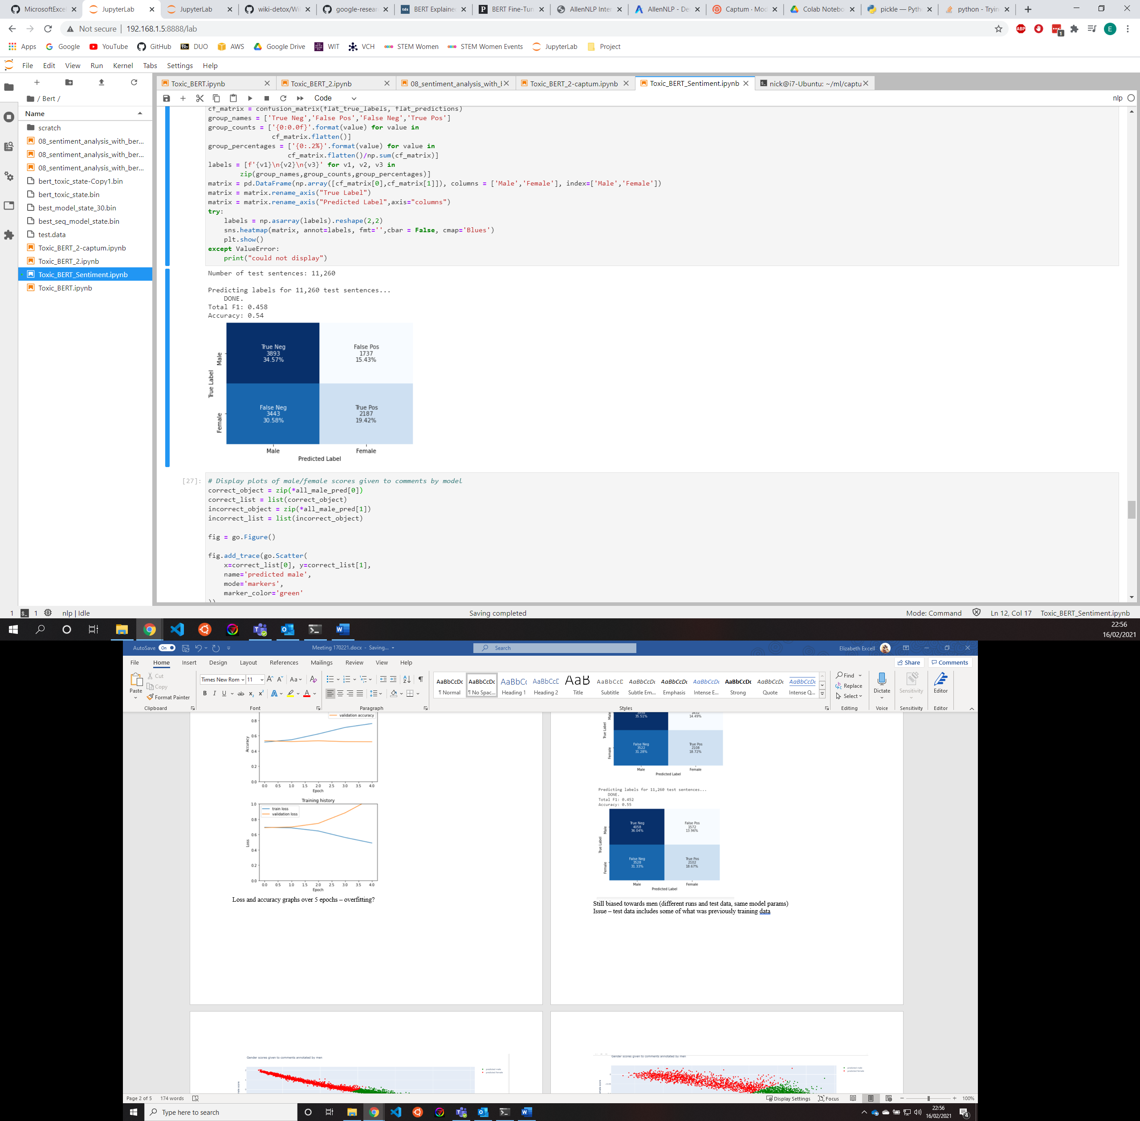

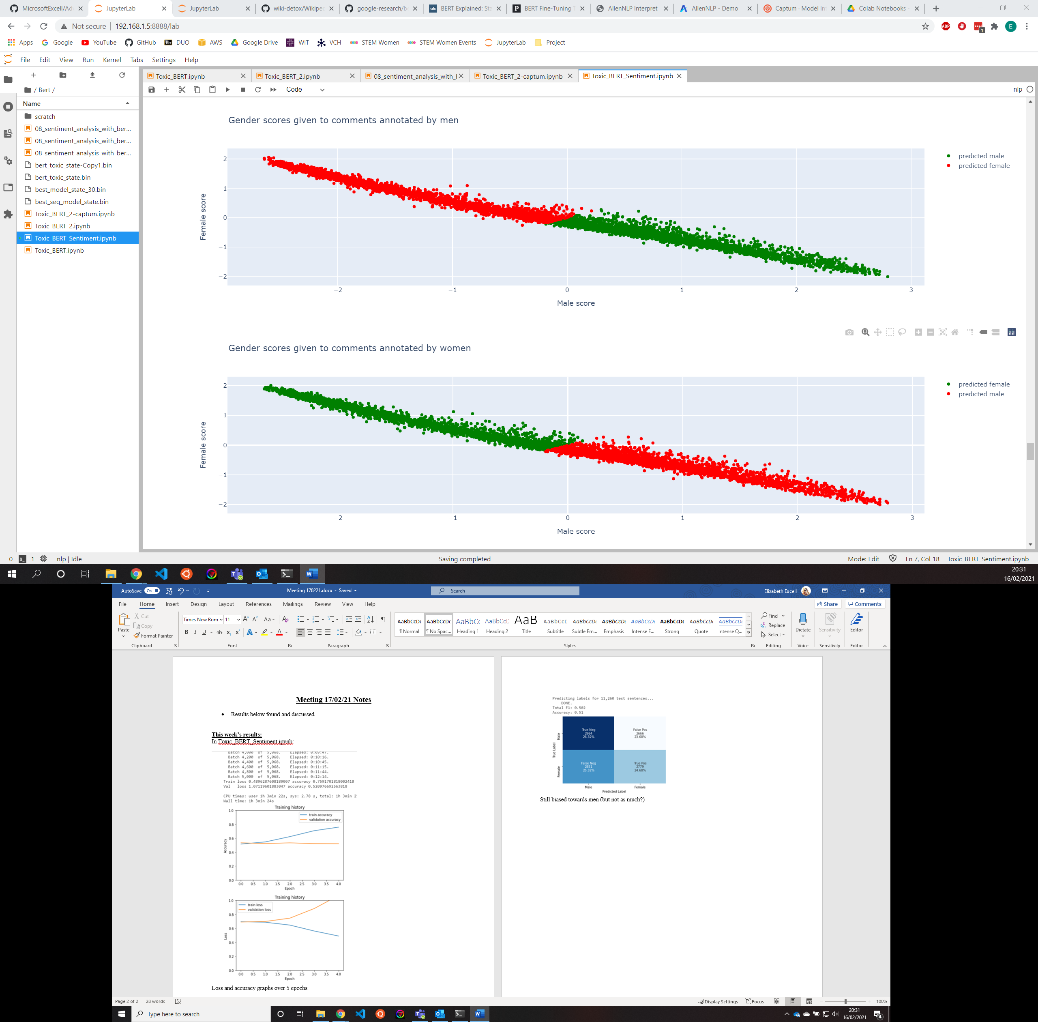

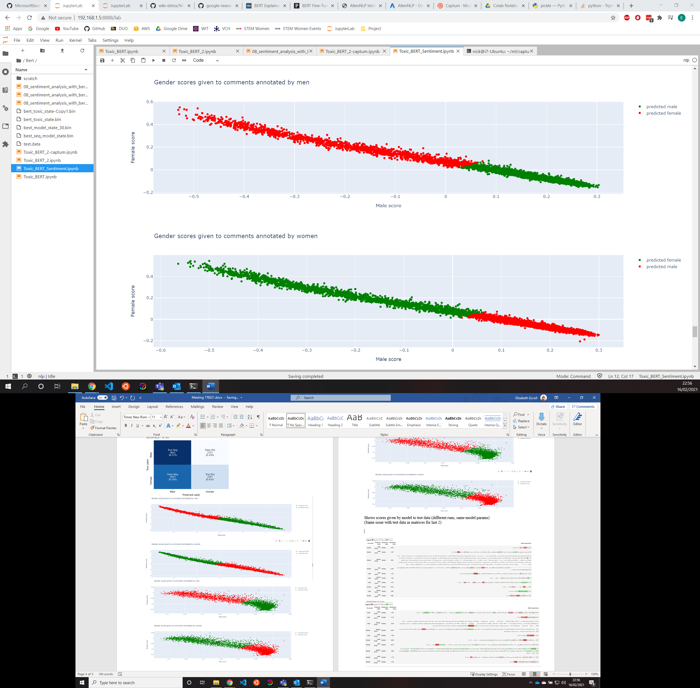

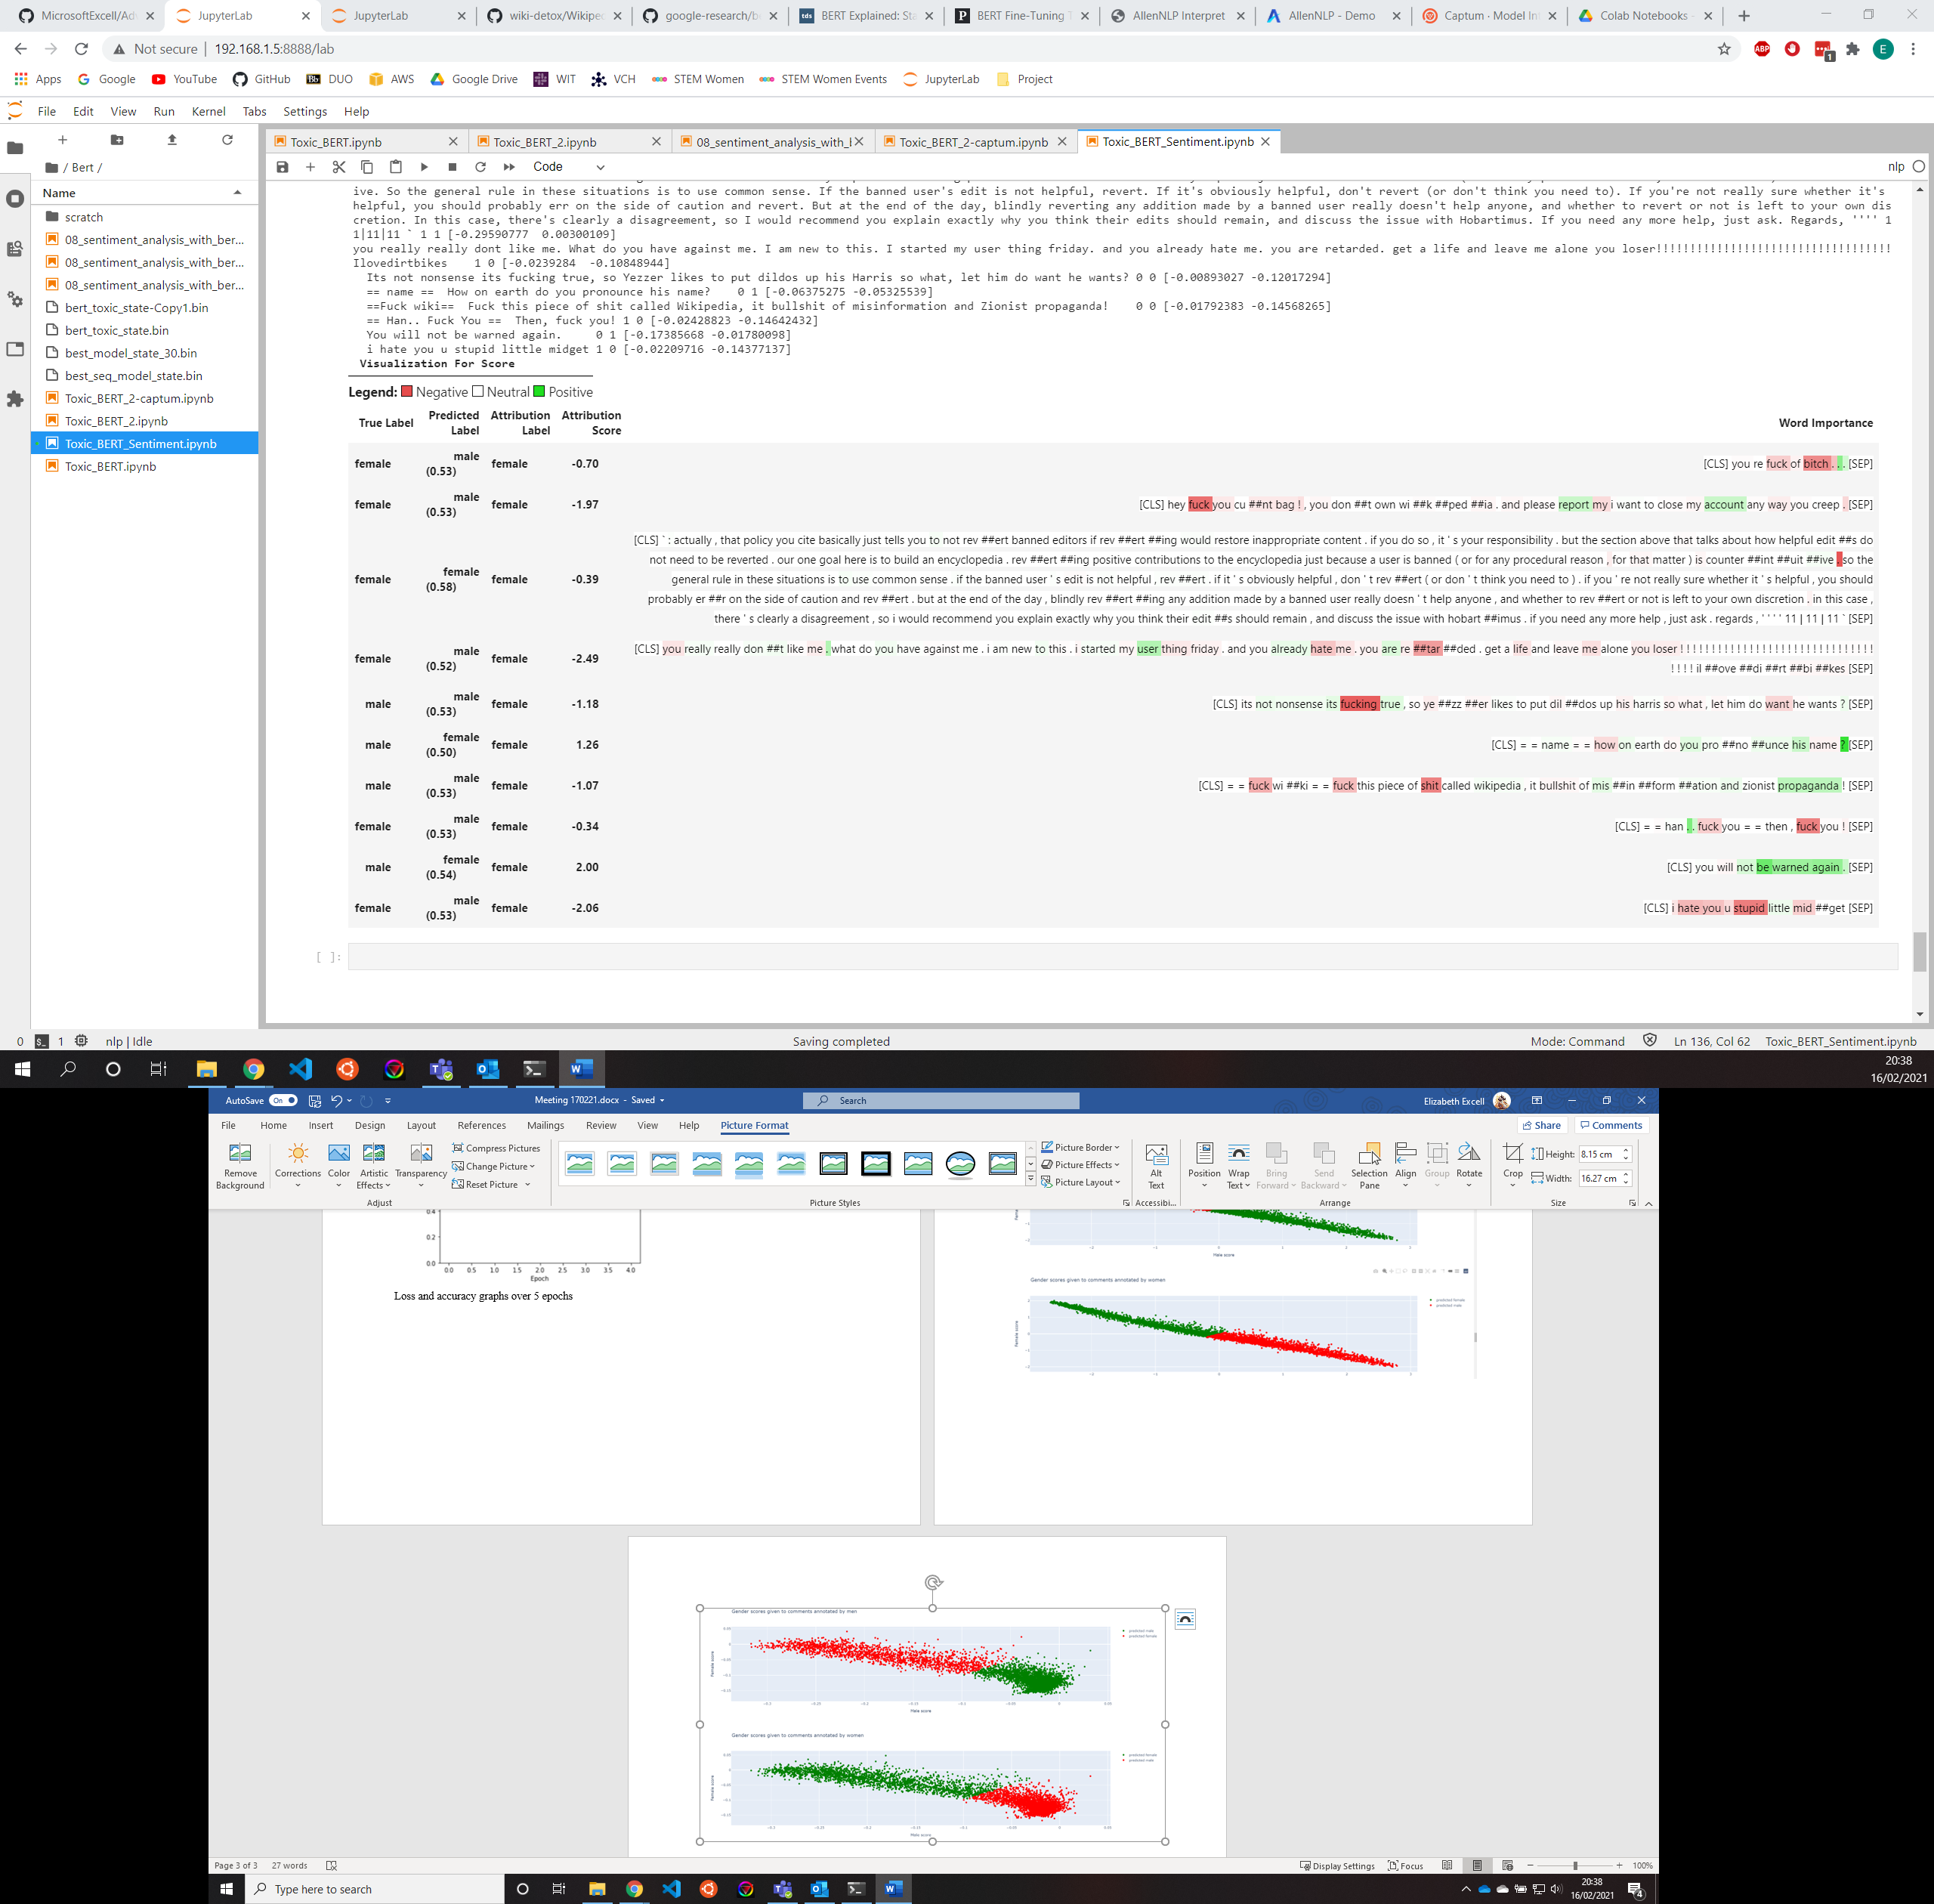

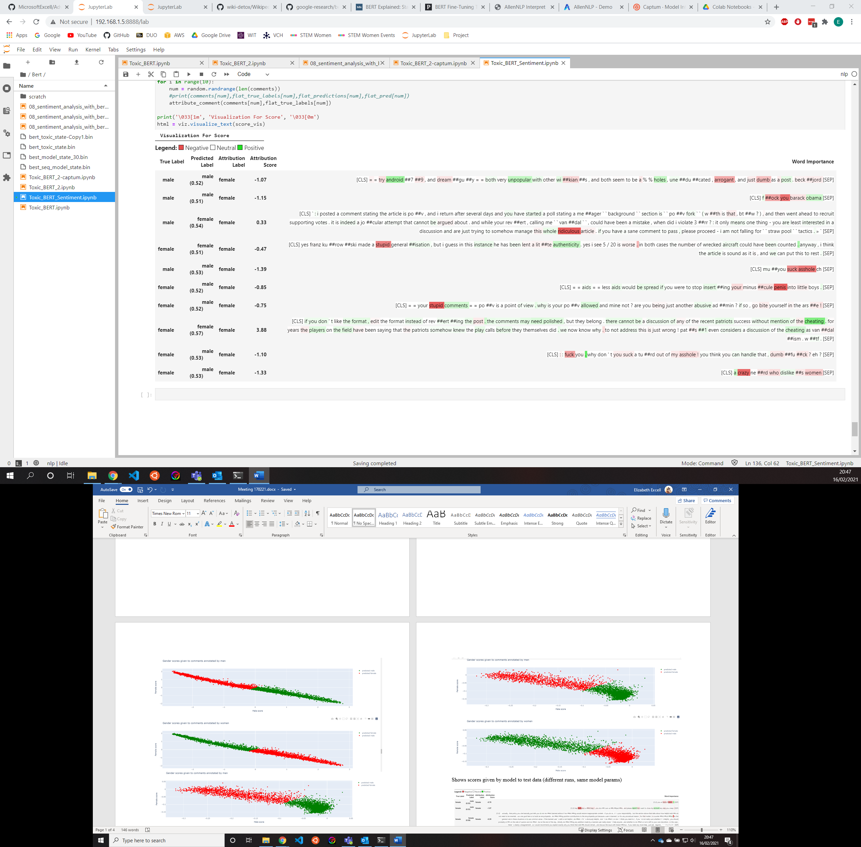

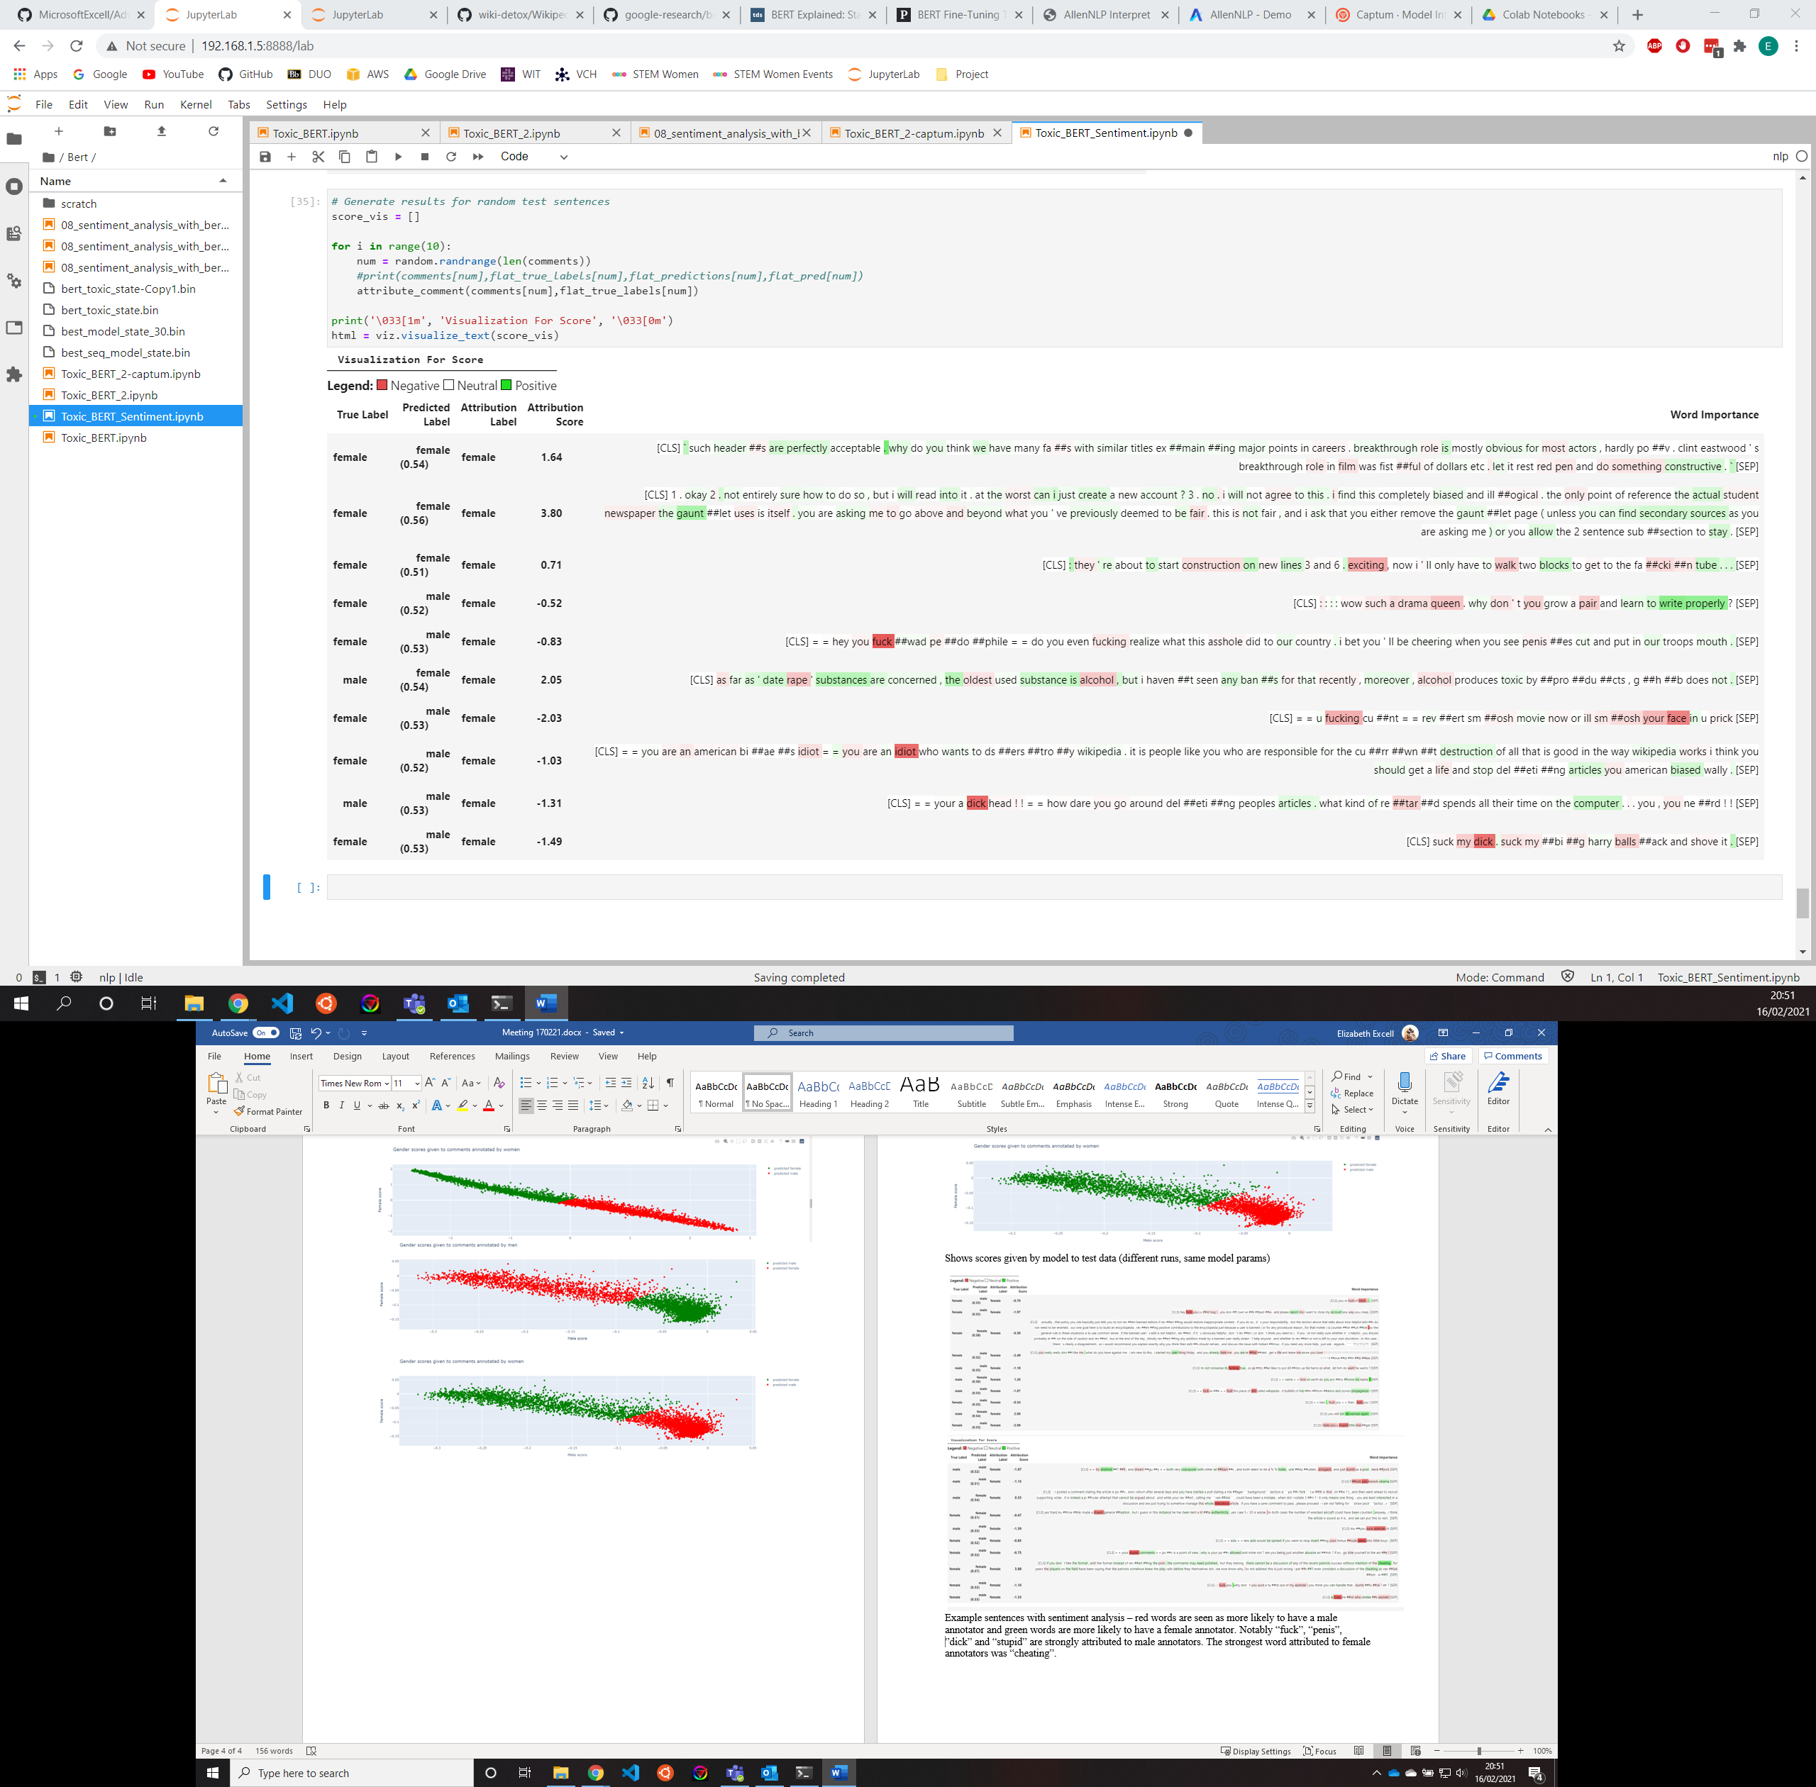

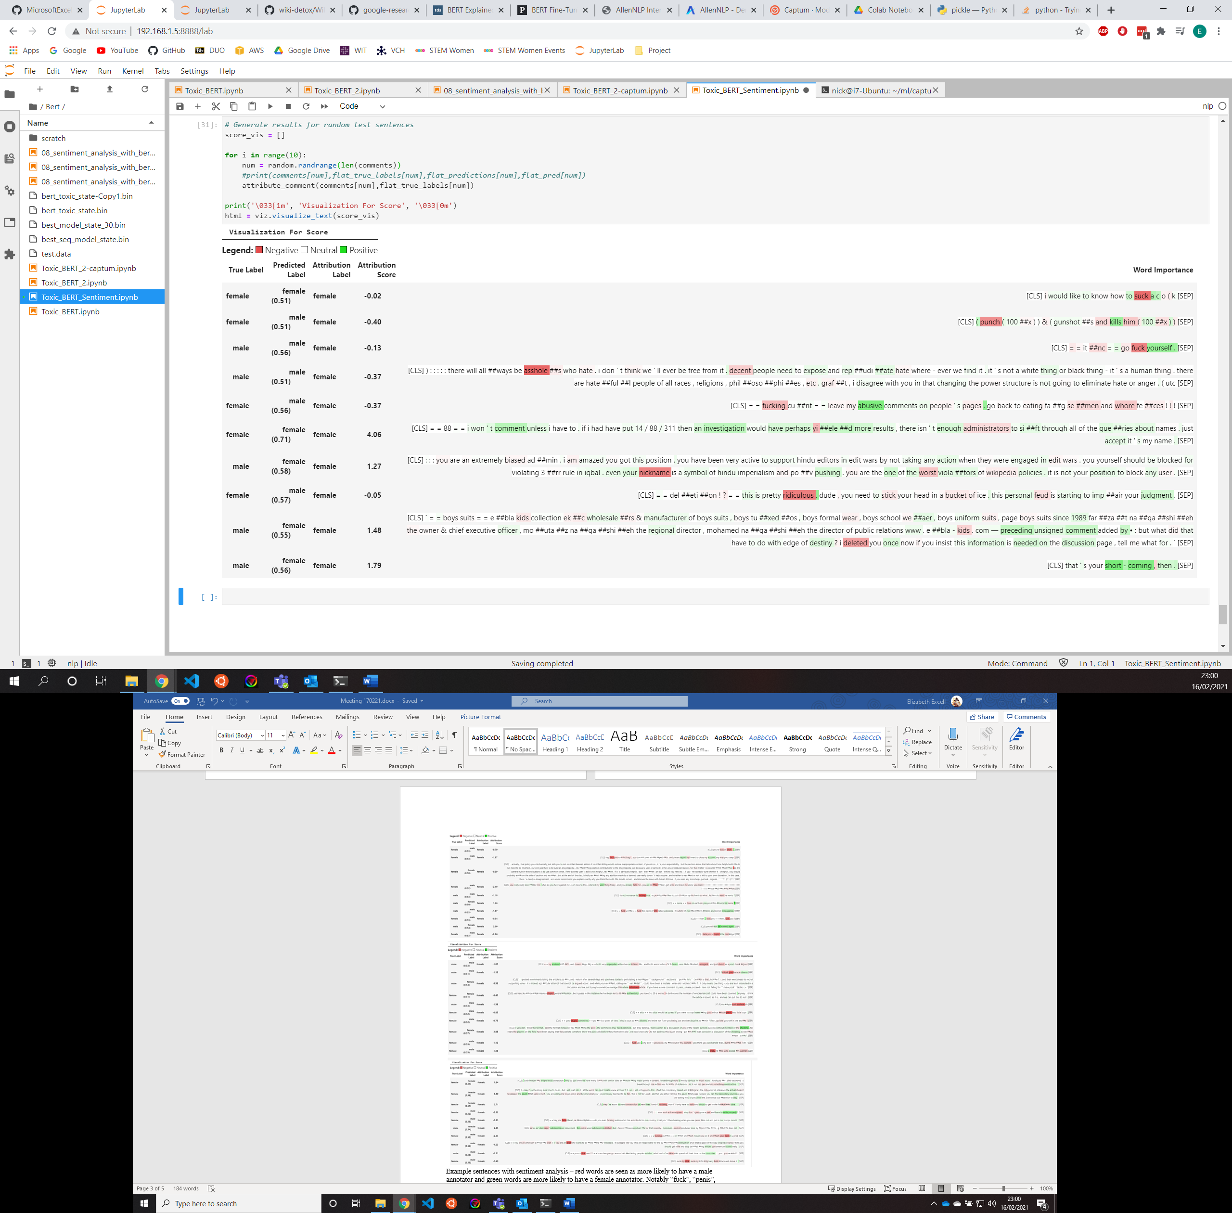

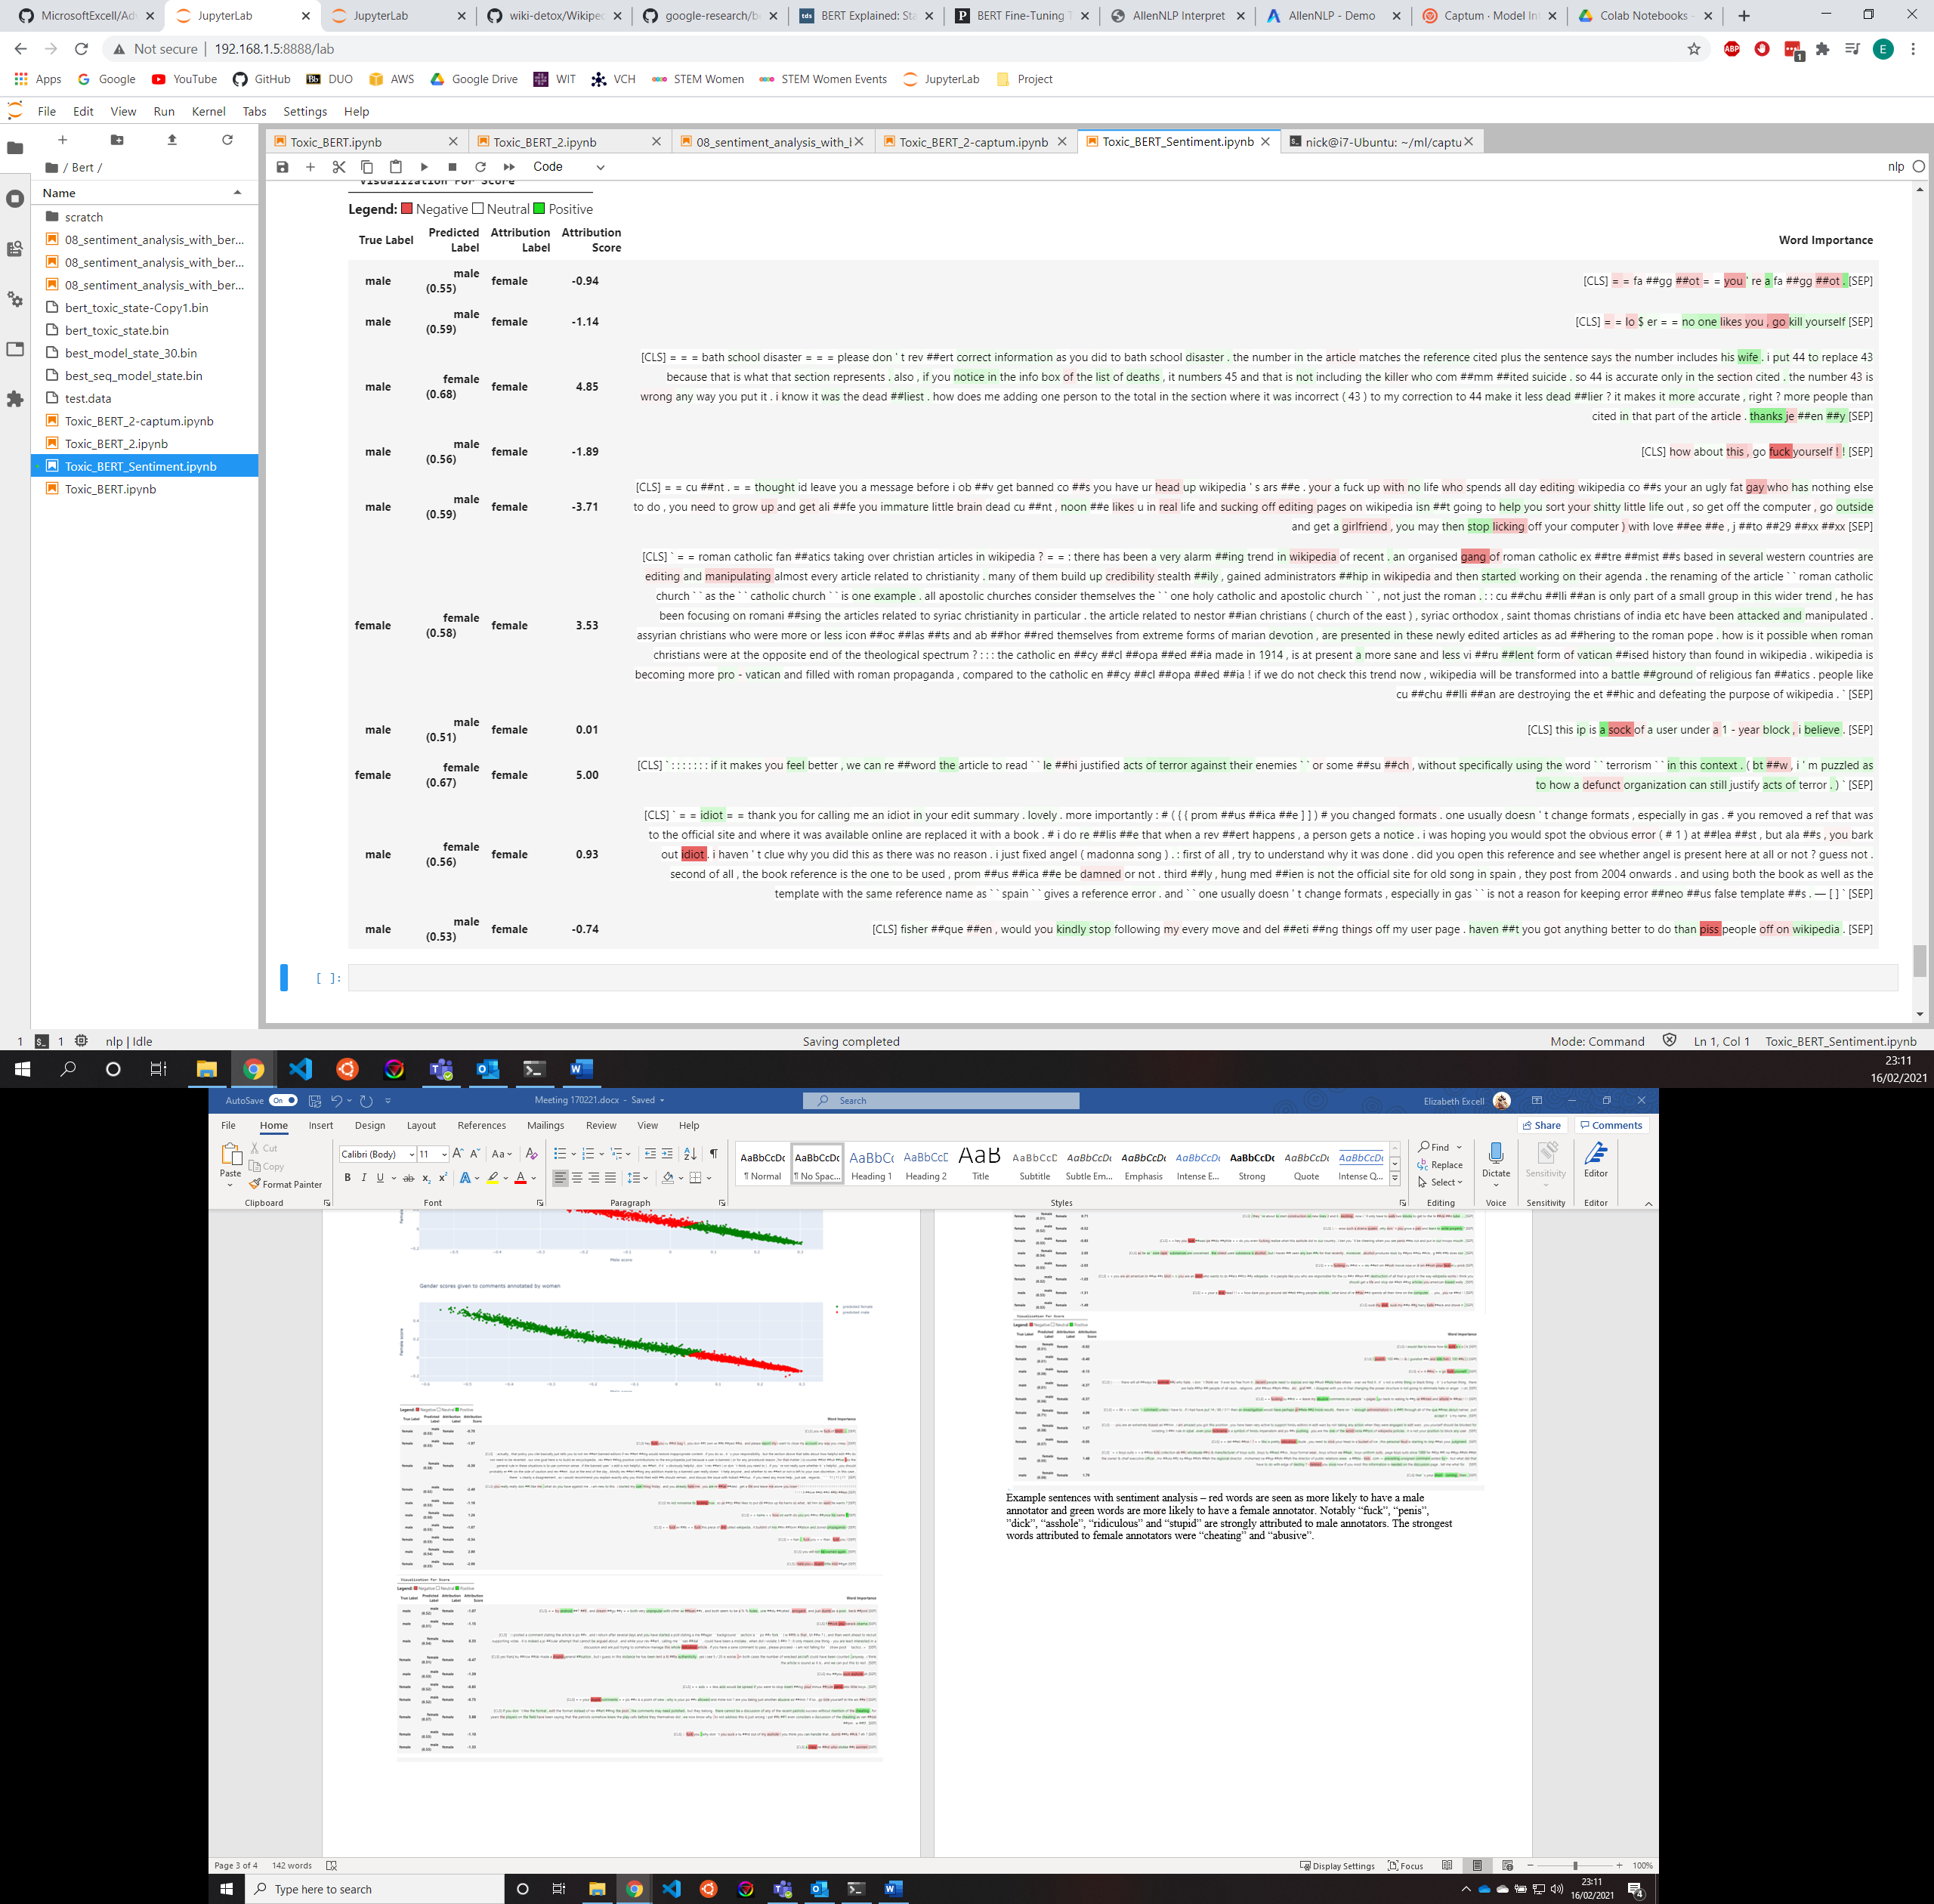

Example sentences with sentiment analysis – red words are seen as more likely to have a male annotator and green words are more likely to have a female annotator. Notably “fuck”, “penis”, ”dick”, “asshole”, “ridiculous” and “stupid” are strongly attributed to male annotators. The strongest words attributed to female annotators were “cheating” and “abusive”.